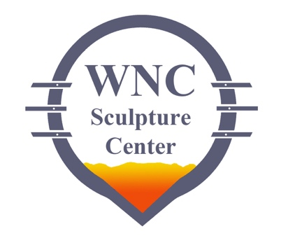
CALL FOR
OUTDOOR SCULPTURE!
2020 Tri State Sculptors Conference
&
WNC Sculpture Center and Park

The Western North Carolina Sculpture Center (WNCSC) is pleased to be teaming up with the Tri State Sculptors Association for this call for outdoor sculpture. During COVID-19 we feel that it is important to continue to offer rich art experiences to our community and the opportunity for sculptors to exhibit their work at North Carolina’s newest sculpture park even while the 2020 conference will occur online. Outdoor sculpture is the safest way to experience art during this time and we are fortunate to be able to do so.
Tri State Members are eligible to submit up to 3 works to this exhibition. Not all works will be guaranteed to be in the exhibition, submitted works must be available to be shown. Multiple works may be selected from an individual sculptor. WNC Sculpture is able to dedicate 10 sculpture pads for masonry anchoring and will prioritize those works where anchoring is a necessity. The sculpture pads average 4’x4’ though there are 2 pads that are larger in size. WNCSC will only be able to accommodate 2 works that exceed a 4’x4’ footprint that cannot be staked to the ground. In the event that more than 10 works which require concrete anchoring are submitted, it will be up to the discretion of the WNCSC Directors to select the work featured on the concrete pads. Additional works will be considered that may be able to be staked to the ground. The founders and directors of WNCSC will evaluate submissions and will make every effort to select at least one work per sculptor. All works must be suitable for outdoor exhibition and meet our quality criteria. Installation works are also eligible for submission. WNCSC includes large meadows, tree lines and trails for installation works (wncsculpture.org). Sculptors will be responsible for lodging should an installation require a multi-day visit.
The exhibition will run for one full year, from September 2020 through September 2021. Prizes will be given to awarded sculptures by an external judge TBD. First place will receive $750.00, second place will receive $500.00 and third place will receive $300.00. We are planning on having a closing reception in September of 2021 the final day of the exhibition, the day before deinstall.* Travel and lodging for the delivery and retrieval of work is the responsibility of the sculptor. All work may be for sale. WNCSC will take a 25% commission on any work sold. Sculptors will be paid within 14 days of the purchase of any work in this exhibition.

Application Deadline: August 14, 2020 at midnight
Notification on selected works: August 28, 2020 via email
Selected sculpture install dates: September 18, 19, 20, 2020
Closing reception: September 17, 2021 5:30 – 8:00 pm*
Sculpture removal dates: September 18, 19, 2021

To submit, please send the following to wncsculpture@gmail.com with “Outdoor Sculpture Submission” in the subject line of the email (there is no application fee for submission):
• at least 3 images of available sculpture in the form of jpgs no less than 1200 dpi in the smallest dimension or as a single pdf. Please ensure that you are submitting quality images, requests may be made to resubmit should images not be conducive to evaluation.
• Sculptor’s name, title, media, dimensions, and please specify if anchoring is needed or staking is permissible. Please provide an image key should more than one work be submitted.

*Reception is pending on the COVID-19 situation. WNCSC will determine by August 31, 2021 if a reception is able to be held while keeping attendees safe. Should the reception be cancelled, participating sculptors will be notified of awarded work by August 31, 2021.

